**3. ReactJS-HOL**

**CalculateScore.js**

import React from 'react';

import '../Stylesheets/mystyle.css';

function CalculateScore() {

const name = "John Doe";

const school = "Greenwood High School";

const total = 450;

const goal = 500;

const average = (total / goal) * 100;

return (

<div className="score-container">

<h2>Student Score Report</h2>

<p><strong>Name:</strong> {name}</p>

<p><strong>School:</strong> {school}</p>

<p><strong>Total Marks:</strong> {total}</p>

<p><strong>Goal:</strong> {goal}</p>

<p><strong>Average Score:</strong> {average.toFixed(2)}%</p>

</div>

);

}

export default CalculateScore;

**mystyles.css**

.score-container {

margin: 40px auto;

padding: 30px;

border: 2px solid #444;

width: 400px;

background-color: #f5f5f5;

text-align: left;

font-family: Arial, sans-serif;

}

.score-container h2 {

color: #2c3e50;

text-align: center;

}

.score-container p {

font-size: 16px;

margin: 8px 0;

}

**App.js**

import React from 'react';

import CalculateScore from './Components/CalculateScore';

function App() {

return (

<div>

<CalculateScore />

</div>

);

}

export default App;

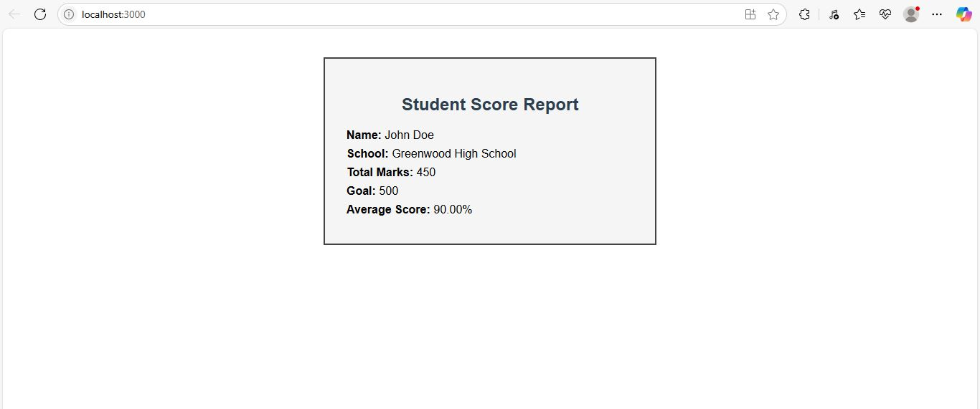

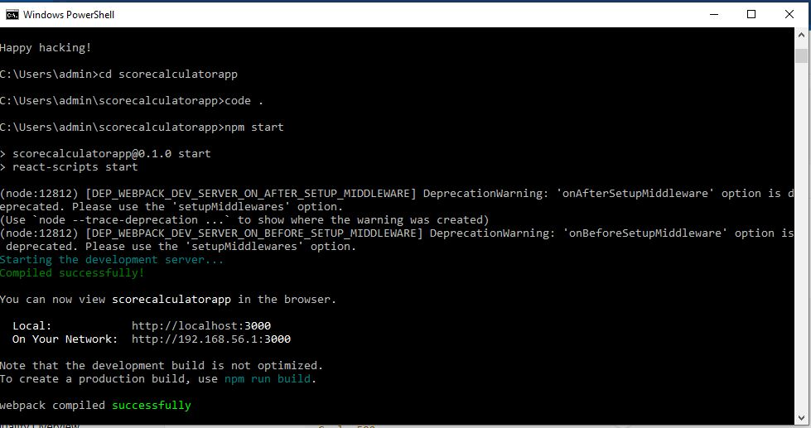

**1. Explain React components**

React components are independent, reusable pieces of UI in a React application. They return JSX to describe what should appear on the screen.

**2. Identify the differences between components and JavaScript functions**

| **Feature** | **React Components** | **JavaScript Functions** |
| --- | --- | --- |
| Purpose | Create UI elements | Perform logic or calculations |
| Return | JSX (HTML-like) | Any data type |
| Usage | Can accept props and manage state | No React-specific behavior |
| Integration | Used inside React rendering | Used for utility or logic |

**3. Identify the types of components**

* **Function components**
* **Class components**

**4. Explain class component**

A class component is a React component defined using ES6 class syntax. It supports state and lifecycle methods.

**5. Explain function component**

A function component is a JavaScript function that returns JSX. Since React 16.8, it can use Hooks to manage state and side effects.

**6. Define component constructor**

In class components, the constructor initializes state and binds methods. It's not used in function components.

**7. Define render() function**

The render() method is used in class components to return the UI. It's not required in function components, which directly return JSX.